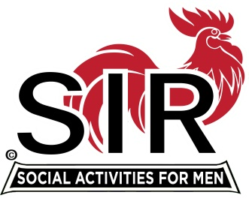
Las Trampas Branch 116
Meeting Agenda
October 19, 2020, 11:45 AM
The Mission of SIR is to enhance the lives of our members through fun activities, events and luncheons – while making friends for life

11:45 Social Time

12:00 BIG Sir: Welcome

12:05 Video: America The Beautiful

12:10 Speaker: Sam

12:50 Little SIR: Speaker “Thanks.”

12:55 Michael: Video. The Nail

1:00 BIG SIR: Bogus email solicitation

1:05 Activities: Fred Wachowicz
Bernie Wroblewski

1:15 Little SIR: Birthday Boys

1:20 Big Sir: Close Meeting

